- The two U.S. Senators who represent me are… (also name their political party). State one of their issues and their stance on that issue. (write the website down in which you obtained this information)

- Who is the House member (Representative) that currently represents this area? What area is included in this district and what party is your Representative affiliated with? State one of their issues and their stance on that issue. (write the website down in which you obtained this information)

- Who is the current Michigan Senator who represents you? State one of their issues and their stance on that issue. (write the website down in which you obtained this information)

- Who is the current Michigan State Representative who represents you? State one of their issues and their stance on that issue. (write the website down in which you obtained this information)

Websites to use:
www.votesmart.org – General information about your representatives.
www.house.gov – website for the U.S. House of Representatives
www.senate.gov – Website for the U.S. Senate
www.house.michigan.gov – Website for the Michigan House of Representatives
www.senate.michigan.gov – website for the Michigan Senate

Numbers:
Members of the House _______ Members of the Senate _______
Term of Senator _______ Term of congressman _______
Senators are chosen ______ (number chosen) every ______ (number of years)

Define:
Apportion

Reapportion

Census

Off-year election

Single-member district

At-large

Gerrymander

- Should there be a constitutional amendment to limit the number of terms of a congressmen such as the system in Michigan? What are benefits and negatives to this plan?

- When are elections for congress (and the president) held?

- What typically happens in off-year elections?

- What did Wesberry v. Sanders decide?

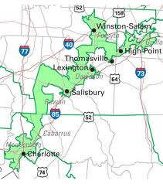
- Is this gerrymandering of the 12th District in North Carolina legal? What questions would you ask to determine that?

- What are the qualifications for the House?

