The amazing man’s
Guide to awesomeness.
By Noah flint
Warnings do take any of this stuff seriously

Step one:
Get ripped Warning this will resolve with many women taking off your shirt and stealing your clothes.

STEP TWO:
GET A MOTORCYCLE OR A MUCLSLE CAR (OR BOTH FOR BETTER RESULTS)

Step three:
Use axe Apollo

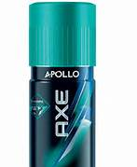

Step four
Get a Tattoo

