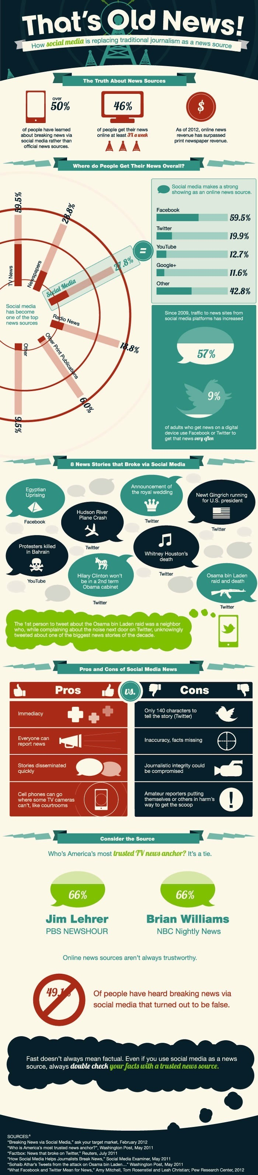
What are pros/cons with getting our news from the following sources as well as their historic impact:

1. Television

2. newspapers

3. radio

4. magazines

5. social media

What are the limits on media influence?

- random sample
- medium
- sample
- straw vote
- quota sample
- interest group
- mass media
- sound bite
- public opinion poll
- opinion leader
- public opinion
- random sample
- mandate
- factors on political socialization

- problems with scientific polling

- purpose of polls

- impact of mass media on population

- universe

- How is public opinion made?

- What would be the best way to learn about public issues?

- Why is public opinion misleading?

- What are problems with measuring public opinions?

- Most reliable measure of public opinion

- Random sampling

- Most dominant form of mass media

- First step in public polling

- Problem with interest groups influencing public policy

- Proper polling behaviors

- Why does Flint love Kevin so much?

