1. What can you tell about Japan by looking at the map?

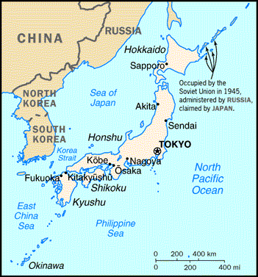

2. Illustrate the power of the Yamato clan – explain your illustrations

3. Explain how your life, the life of someone you know or the life of someone famous would be an honorable follower of Shintoism.

The essence of Shinto is the Japanese devotion to invisible spiritual beings and powers calledkami, to shrines, and to various rituals.
Shinto is not a way of explaining the world. What matters are rituals that enable human beings to communicate with kami.
Kami are not God or gods. They are spirits that are concerned with human beings - they appreciate our interest in them and want us to be happy - and if they are treated properly they will intervene in our lives to bring benefits like health, business success, and good exam results.
Specifically Shinto ethics are not based on a set of commandments or laws that tell the faithful how to behave, but on following the will of the kami. So a follower of Shinto will try to live in accordance with the way of the kami, and in such a way as to keep the relationship with the kami on a proper footing.
But it's important to remember that the kami are not perfect - Shinto texts have many examples of kami making mistakes and doing the wrong thing. This clear difference with faiths whose God is perfect is probably why Shinto ethics avoids absolute moral rules.
The overall aims of Shinto ethics are to promote harmony and purity in all spheres of life. Purity is not just spiritual purity but moral purity: having a pure and sincere heart.

No moral absolutes
Shinto has no moral absolutes and assesses the good or bad of an action or thought in the context in which it occurs: circumstances, intention, purpose, time, location, are all relevant in assessing whether an action is bad.

Good is the default condition
Shinto ethics start from the basic idea that human beings are good, and that the world is good. Evil enters the world from outside, brought by evil spirits. These affect human beings in a similar way to disease, and reduce their ability to resist temptation. When human beings act wrongly, they bring pollution and sin upon themselves, which obstructs the flow of life and blessing from the kami.

Things which are bad
Things which are usually regarded as bad in Shinto are:
- things which disturb kami
- things which disturb the worship of kami
- things which disrupt the harmony of the world
- things which disrupt the natural world
- things which disrupt the social order
- things which disrupt the group of which one is a member

4. How did cultural diffusion take place between China, Japan, and Korea? (all in the book)
Korea China Japan

5. Imagine the Heian Court was now at Hanover-Horton. Develop a way to make an act, event or everyday occurrence into a more sophisticated ceremony. (7 parts)

6. Create a poem under the style of The Tale of Genji during the Heian period. Use the word “summer” as your rhyme word.

7. Write your Code of Bushido for an athlete, boyfriend/girlfriend, son/daughter, student, or employee. (7 codes)

8. Create a different chart than the one on 392 to show the interconnectedness of the people in Japan.

9. State something you do that is Zen and describe how it is Zen. (incorporate 3 of the Zen ideas)

