1. Describe Christopher Columbus. Why is there a holiday named after him?

Name of explorer/sponsor | Location(s) traveled | Purpose | Accomplishment

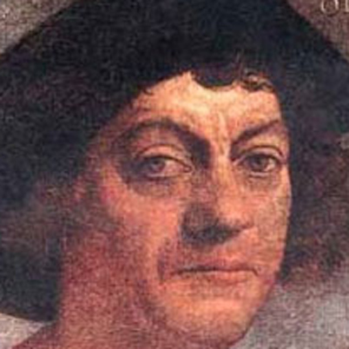
Who is this?

