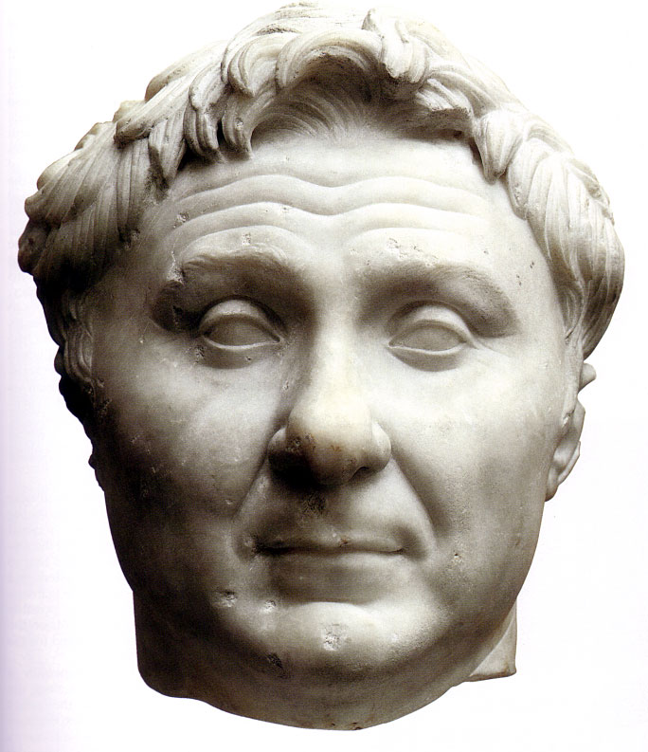
Pompey or Cnaeus Pompeius Magnus, was born on Sept. 29, 106 B.C., into a family of moderate distinction at Rome. His father, Pompeius Starbo, was one of the most successful and independent Roman generals in the war against Rome's former Italian allies (90 B.C.). Pompey himself first came to public attention when he raised troops for the support of Lucius Cornelius Sulla when Sulla returned from the East to challenge the followers of Gaius Marius. Pompey won victories for Sulla in Sicily and exacted a triumph from him.
Soon after the abdication of Sulla, Pompey showed that he did not regard himself bound by the strict provisions of the Sullan constitution. He secured from the Senate a special command against the rebel proconsul M. Aemilius Lepidus (77 B.C.), in spite of the fact that he was below the age established by the Sullan constitution for magistracies and commands. His success against Lepidus was followed by another special command against Sertorius. Sertorius, a former supporter of Marius, had fled to Spain after the defeat of the Marian faction and was waging a series of masterful guerrilla wars against Roman armies sent against him.
Pompey arrived in Spain in 76 B.C. A series of indecisive campaigns followed, with Pompey gaining slight advantages until Sertorius was murdered by one of his officers in 72 B.C. Following his victory, rather than spreading massive destruction, Pompey pursued a humane policy of granting citizenship and founding permanent settlements in Spain to ensure peace.
Consul and Reformer
After 5 years' absence, Pompey returned to Italy. He took some of the credit for the suppression of Spartacus's revolt by eliminating some elements of the gladiators' army. The result of these successes propelled Pompey together with M. Licinius Crassus, the real victor over Spartacus, into the consulship for the year 70 B.C. This again was contrary to the Sullan decrees, since Pompey had held no previous regular political office in Rome. The two men presided over the dismantling of certain elements of Sulla's constitution.
The tribunate, which had been used by the Gracchi in the late 2nd century to push popular reform, had been stripped of almost all power by the conservative Sulla. Now Pompey and Crassus restored most of its old strength, and it became a potent instrument in the power struggles of the last years of the republic. Gaius Sempronius Gracchus had limited membership on the courts which tried Roman governors for extortion to the financial class (equestrians), and Sulla had returned control to the Senate. Now the courts were entrusted to a mixed body of senators and equestrians.
Pirate Wars and Mithridates
The next major challenge came to Pompey in 67 B.C., when he was charged with suppressing the pirates. The piratical menace had grown as the result of Rome's shortsighted suppression of the power of the Greek island of Rhodes in the 2d century B.C. Rhodes had for years kept the Mediterranean free of pirates. Now they even raided the Roman seaport of Ostia.
Pompey received a command which provided him with complete power at sea and power equal to that of any governor for 50 miles inland. Furthermore, he was granted the right to appoint 24 legates so that he could divide the Mediterranean among various subordinates and coordinate the sweeps against the pirates. The success of his planning was shown by the fact that the pirate danger was eliminated within a year. In victory, Pompey again showed a sensible humanity by settling pacified pirates in communities where they could follow peaceful activities.
This amazing triumph over the pirates led to Pompey's command against Rome's second current menace, Mithridates. This king of Pontus had been a thorn in the side of Rome for nearly 20 years. Several times he had been defeated but had always recovered. Now the Roman general Lucullus, who seemed to have finally suppressed Mithridates, was faced with an army in mutiny and political resistance at home. When Pompey received this command, which granted him almost unlimited powers in the East, in 66 B.C., Mithridates saw his days numbered and had himself killed by one of his own bodyguards. Pompey then toured the East, absorbing territories such as Syria into the empire, making treaties with many of the Asiatic princelings, founding cities, and building up vast support for himself.
The Triumvirate
However, in 62 B.C. Pompey had to return to Rome to get his agreements ratified by the Senate and rewards provided for his soldiers. He had relatively little experience in senatorial politics and discovered that the senatorial oligarchy tended to unite against powerful individuals. Pompey's political program was soon in trouble, and he had to turn to the wealthy and influential Crassus and to Julius Caesar, the consul for 59 B.C. They formed the political alliance known as the Triumvirate. Caesar used his own skill, as well as Pompey's and Crassus' resources, to pass the bills that Pompey wanted.
In spite of his difficulties with the Senate, Pompey was still the most important individual in Rome. His wealth from his Eastern connections was enormous, and he displayed it by such activities as building Rome's first stone theater. The next decade was to test all his skills. By 58 B.C. Rome was virtually ruled by political mobs like that led by P. Clodius Pulcher. Pompey was not able to control these and at one time was even forced to barricade himself in his house. Still he was the man to whom Rome turned in hours of crisis. In 57 B.C., when there was a shortage of grain, Pompey again received a special commission to deal with the crisis. In 55 B.C., after the Conference of Luca had patched up the Triumvirate, he was again consul. Following this, he received the proconsulship of the two Spains with the right to administer provinces in absentia. In 52 B.C., when after the murder of Clodius rioting engulfed Rome, he was chosen sole consul, an unprecedented step.
Meanwhile, events outside Rome were shifting the balance of power and the alliance of parties. In 59 B.C. Caesar had been a useful but not an overly powerful individual. After years of successful campaigning in Gaul, he had enormous prestige, great wealth, and a tough, loyal army. Gradually the links between him and Pompey were dissolved. The Conference of Luca had temporarily patched up their alliance. However, in 54 B.C. a major link between the two was broken when Julia, daughter of Caesar and wife of Pompey, died. She had been loved by both men and must have done much to hold them together. The sense of confrontation was increased in 53 B.C., when the third triumvir, Crassus, was killed fighting the Parthians. The fear of Caesar now drove Pompey and the Senate increasingly together.
The real crisis erupted when Caesar's command in Gaul came to an end. A faction in Rome was awaiting the day when Caesar lost his proconsular immunity and could be tried for his activities as consul and proconsul. Caesar saw this and demanded the right to stand for the consulship without leaving his province. Pompey was caught in the middle between the ambitious Caesar and an obdurate band of senators. Finally, the Senate forced the issue, and Caesar chose war.
Civil War
Pompey decided quickly that his best chance of success lay in rallying his support in the East. He abandoned Italy to Caesar and moved to Greece. Although he had the reputation of being Rome's greatest marshal, he had not been to war for over a decade, so the loyalty of old soldiers had cooled. Caesar, on the other hand, came fresh from the field of battle with a hardened army. Moreover, Caesar fought for his own interest, whereas Pompey was the general of the Senate. As such, he had to pay heed to the numerous senators who crowded his camp. In the end Caesar proved the superior strategist and tactician.
After securing his position in Italy and the West, Caesar moved against Pompey in Greece. Pompey managed to avoid being trapped at Dyrrhachium and followed Caesar's army as he retreated into Greece. The two met on the field of Pharsalus (Aug. 9, 48 B.C.), and Caesar, although outnumbered, displayed greater tactical ability, and Pompey fled in defeat. When he landed in Egypt, he was murdered at the orders of Ptolemy, the ruler of Egypt.
After his arrival in Egypt, Pompey's fate was decided by the counselors of the young king Ptolemy XIII. While Pompey waited offshore, they argued the cost of offering him refuge with Caesar already en route to Egypt: the king's eunuch Pothinus won out. In the final dramatic passages of his biography, Plutarch had Cornelia watch anxiously from the trireme as Pompey left in a small boat with a few sullen, silent comrades and headed for what appeared to be a welcoming party on the Egyptian shore. As Pompey rose to disembark, he was stabbed to death by his betrayers Achillas, Septimius and Salvius. Plutarch has him meet his fate with great dignity, one day after his 59th birthday. His body remained on the shoreline, to be cremated by his loyal freeman Philip on the rotten planks of a fishing-boat. His head and seal were later presented to Caesar, who not only mourned this insult to the greatness of his former ally and son-in-law (he wept when he received Pompey's seal, on which there was an engraving of a lion holding a sword in his paw), and punished his assassins and their Egyptian co-conspirators, putting both Achillas and Pothinus to death. Pompey's ashes were eventually returned to Cornelia, who carried them to his country house near Alba.^{[53]} Cassius Dio describes Caesar's reactions with skepticism, and considers Pompey's own political misjudgements, rather than treachery, as instrumental in his downfall.^{[54]} For Pliny, the humiliation of his end is anticipated by the vaunting pride of Pompey's oversized portrait-head, studded entirely with pearls, carried in procession during his greatest Triumph.

