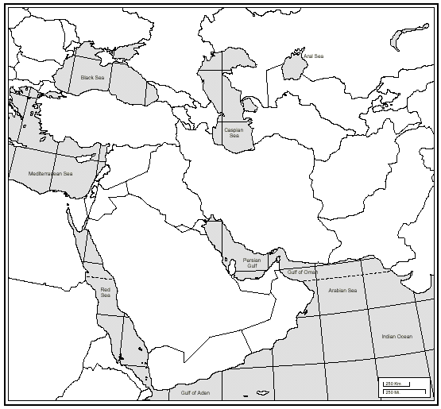

1. ______________________

2.______________________

3. _____________________

4. _____________________

5. _____________________

6. _____________________

7. _____________________

8. _____________________

9. _____________________

10. ____________________

11. ____________________

12. ____________________

13. ____________________

14. ____________________