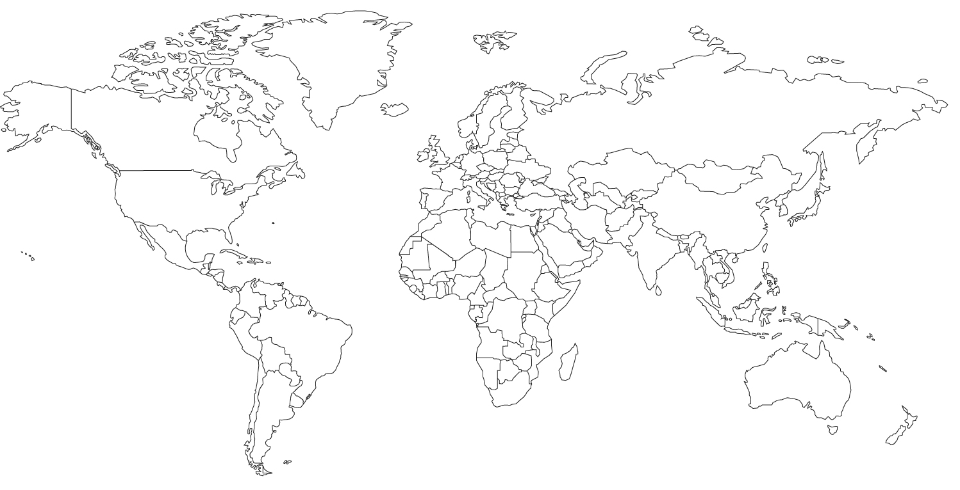
In different colors (no shading) draw in the routes of Dias, Da Gama, Columbus, Balboa, Magellan, Cabot, Cartier, Hudson
Label the following: Moluccas (Spice Islands), Portugal, Spain, France, Great Britain, Netherlands, Azores, West Indies, Ottoman Empire, Mughal Empire, Songhai, Cape of Good Hope, Italy, East Indies, Strait of Magellan, Cape Town, China, Macao

