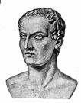
Julius Caesar was born to patrician parents but not into a position of wealth and power. His father, Gaius Julius Caesar, was a praetor (an important position in government). His mother, Aurelia, was more well known as the sister of Julia, the wife of Gaius Marius, who was at the time the leader of a group of Romans known as the Popular group.
When young Julius (as he preferred to be known, dropping his real first name, which was Gaius just like his father's) was 15, his father died. He spent a few years making a name for himself in the military and then got married, to a woman named Cornelia, who was the daughter of an important man in the Popular group. A few years into their marriage, Cornelia gave birth to a daughter, Julia.
Things changed when Sulla ruled the Roman government as dictator. For one thing, Sulla ordered Julius to divorce Cornelia, since she was from the family of one Sulla's enemies. Caesar refused and instead went into hiding, in order to avoid a certain death sentence for refusing to obey the dictator's wishes. He was eventually pardoned and later returned to Rome when Sulla died, in 78 B.C.
Julius continued to grow as a soldier, distinguishing himself in battle against Rome's many enemies and saving the lives of fellow soldiers in the process. He was also kidnapped in 75 B.C. and held for ransom by pirates from Cilicia, a nearby land. When he found out that they were asking 20 talents to be paid for his release, he is said to have insisted that he was worth at least 50.
He was elected military tribune in 72 B.C. He was also making a name for himself as a lawyer and public speaker. He was elected quaestor in 68 B.C. and, therefore, got a seat in the Senate. He also married Pompeia, Sulla's granddaughter.
Caesar continued to rise in the rankings of government, being elected pontifex maximus (chief priest) and then praetor. He also continued his military successes and was elected consul, in 60 B.C.
The consulship was the top job in government at the time, but Caesar wasn't the only consul. In fact, Rome already had two consuls, Crassus and Pompey.
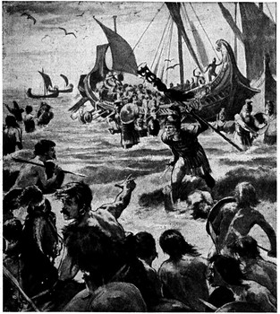
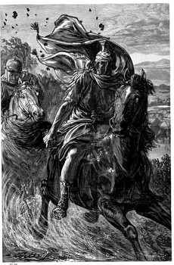
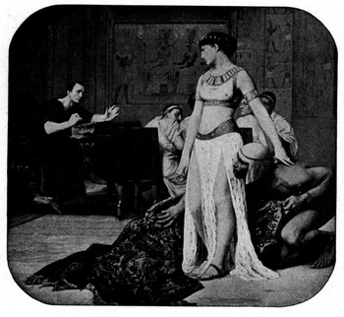
Pompey was a great general who had great successes in the field. He won a series of great victories in Asia and returned to Rome in 62 to ask the Senate to approve of the territory arrangements that he had made as a result of his victories on the battlefields. Crassus, who was quite jealous of Pompey's war successes, persuaded the Senate not to approve of Pompey's plans.
Caesar, sensing an opportunity, persuaded the two consuls to work together and promised to support both of them. His price: a consulship of his own. Crassus and Pompey agreed, and 60 B.C. saw the formation of the First Triumvirate. (Pompey, who might have been suspicious of Caesar's motives at this time, was probably pacified by his new wife, who happened to be Caesar's daughter, Julia.) Caesar had also taken a new wife himself, by the name of Calpurnia.
Within a year, Caesar was true to his word: Pompey's proposals were approved, so were Crassus's and Caesar himself was granted a five-year term as proconsul of Gaul after his tour of duty as a consul had finished.
He left for Gaul in 58 and ended up staying there for nine years. During this time, he directed great military victories but also personally killed or had killed a great many people who stood in his way. The Gaul that he conquered included what is now France, Belgium, southern Holland, Germany west of the Rhine River, and most of Switzerland.
He led expeditions across the English Channel to Britain in 55 and 54 B.C. Neither expedition succeeded in establishing a permanent base. The Roman "civilization" of Britain would have to wait.
With Caesar making a name for himself with his great victories in Gaul and his attempts at subjugating Britain, Crassus and Pompey grew jealous (and, many historians argue, rightfully so). They had been in power and winning wars before Caesar happened on the scene, and they didn't like him getting most of the credit for Rome's recent successes. Itching for victories, Crassus requested and received command of the armies of the East. His reward was a quick death in a battle against the Parthians. Pompey, meanwhile, was increasingly an enemy of Caesar, mainly because nothing kept them together anymore. Julia, Caesar's daughter and Pompey's wife, had died in childbirth in 54. With Crassus gone, the two great generals were suspicious of each other, and each wanted to be sole consul. In 49 B.C., Caesar made the calculated move of bringing his armies across the Rubicon River and into Rome proper. This was against the laws of Rome (which stated that a general could not lead his armies into the home province). As such, it meant civil war. Pompey, whose legions were in Spain, couldn't do much to oppose Caesar at the time and so sailed to the East. Caesar, in the meantime, marched into Rome and had a new Senate installed. This group, which was naturally favorable to him, had him named dictator.
Pompey, meanwhile, was in a strong position in Greece. In order to solidify his claim as head of the government, Caesar had to convince Pompey to give up his claims. Pompey wouldn't do it, and so their struggle came to blows.
The epic struggle took place on the plains of Pharsalus, with Pompey sporting 46,000 men to Caesar's 21,000. Both men were brilliant generals with many victories under their belts by this time. On that day, however, Caesar was the more brilliant, defeating Pompey's forces (although the death toll on both sides was steep). Pompey escaped and fled to Egypt, where he was later betrayed and killed.
After this historic victory, Caesar took the unusual step of pardoning all Roman citizens who were captured. One of those pardoned was Marcus Brutus.
After his success at Pharsalus, Caesar moved to consolidate his position, especially in Egypt. He landed in Alexandria and became involved with Cleopatra, who was in the middle of a power struggle over the Egyptian throne. The wily queen-to-be had herself wrapped in a rug, a gift for Caesar, and delivered to the dictator. Impressed with her cleverness, Caesar listened to Cleopatra's pleas and agreed to help her. During the ensuing struggle for the throne, a great battle took place in and around Alexandria. Among other things, Caesar ordered the Egyptian fleet burned. In a great blow to history, the Great Library also went up in flames. Finally, in 47 B.C., Cleopatra was named Queen of Egypt, in alliance to Rome.
Flush with success in Egypt, Caesar marched on into Asia Minor. On August 1, 47 B.C., he put down a rebellion by a minor king named Pharnaces. Describing this victory, Caesar uttered the words veni, vidi, vici ("I came, I saw, I conquered."). Two months later, he was back in Rome, where new problems awaited him.
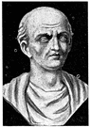
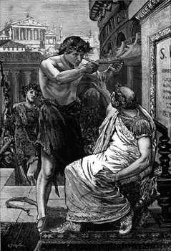
An outspoken opponent of Caesar for many years had been Cato, a brilliant speaker who saw in Caesar a man who would put himself first, before Rome or its people. Cato, already famous before Caesar arrived on the scene, allied himself with Caesar's political opponents. After Caesar's string of victories in the East, Cato and others of Caesar's opponents fled to Africa. Caesar, having returned to Rome, went to Africa and defeated his opponents there, at the Battle of Thapsus. Cato, unable to bear the shame of being defeated or pardoned, killed himself.
Another group of opponents of Caesar was still in possession of some power at this time. Among these men was Senator Gaius Cassius Longinus, who had sided with both Crassus and Pompey against Caesar. Cassius feared that Caesar would proclaim himself king, something that Senators and Romans alike desperately wanted to avoid. The seven kings of Rome had been especially cruel, both their foreign enemies and to the people Rome. The Roman Republic was formed in large part to prevent another king from taking power, and the Senate considered themselves guardians of that trust. In Caesar, Cassius, Cato, and others (including Brutus) saw a new candidate for kingship and a return to the cruelty of the past. A king, after all, or a dictator had to answer to no one. The Republic and its Senate were founded on the idea that people could have a say in their government and that they would not be commanded or dictated to by someone who has claimed power by way of divine guidance or military superiority.
With few opponents left, Caesar got down to the business of governing Rome (by himself, of course). During this time, he did many things that endeared him to the soldiers and to the common people of Rome. He got Rome out of the enormous financial debt that it had been in (in no small part because of the civil wars that he helped create). He increased the number of Senators (with men favorable him taking the new seats). He regulated the amount of grain that could go out to people in need (so that the corruption of past years would not favor the rich anymore). He also reformed the calendar, bringing it up-to-date and ending many years of confusion.
Among other things he did, these reforms alienated many of the rich and powerful who had supported Crassus, Pompey, Sulla, and others who had stood in Caesar's way. Gnaeus and Sextus, Pompey's sons, led a revolt in Spain. Caesar personally led the army that defeated them.
Caesar also had coins made with his face on them and had statues of him dressed up just like statues of the gods. He was also being granted many new titles and privileges by the Senate, including the title of "the unconquerable god" and the right to wear a purple and gold toga and sit in a gilded chair at all public functions. Two tribunes, Gaius Marullus and Lucius Flavius, stated their opposition to such titles and privileges and found themselves removed from the Senate.
In February of 44 B.C., Caesar was named dictator for life. On February 15 of that year, at the feat of Lupercalia, Caesar's trusted lieutenant, Marc Antony, offered the dictator a crown. Caesar, seeing that even though he had tremendous popular support his people still didn't want a king, refused the crown--three times.
Caesar was scheduled to leave March 18 for an expedition against the Parthians, who had killed Crassus. He went to the Senate on March 15 to meet with the Senate one last time before his departure.
The Senate at that time was meeting in the theater built by Pompey because the regular meeting house had been burned and was being rebuilt. So it was that when the 60 conspirators attacked Caesar and killed him with daggers that they had concealed under their togas, it was at the base of a statue of Pompey himself.
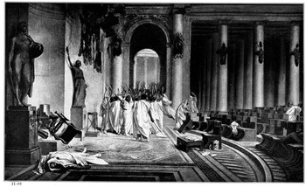
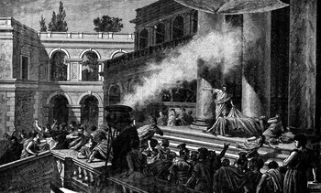
One of the conspirators was Marcus Brutus, whom Caesar had pardoned at Pharsalus and who had been Caesar's trusted adviser. Other Senators in the conspiracy were Gaius Cassius Longinus and Decimus Brutus Albinus.
Though known for their long-range planning and attention to detail, these Senators didn't have a plan beyond ending Caesar's life. Once they had killed him, they fled, leaving the control of Rome to Marc Antony, Caesar's most trusted lieutenant and by this time head of an entire legion of soldiers.
Antony it was who delivered the famous oration at Caesar's funeral, naming and blaming the chief assassins. Antony it was who then became consul in his own right, part of the Second Triumvirate, which also contained Caesar's nephew, Octavian. And it was this young man, following in the footsteps of his uncle, who took the reins of power and became what Julius Caesar had dreamed of becoming: emperor of Rome.

