Define:
Feudalism
Vassals
Fief
Feudal contract
Knight
Tournaments
Eleanor of Aquitaine
Chivalry
Troubadours
Serfs
Liege Lord
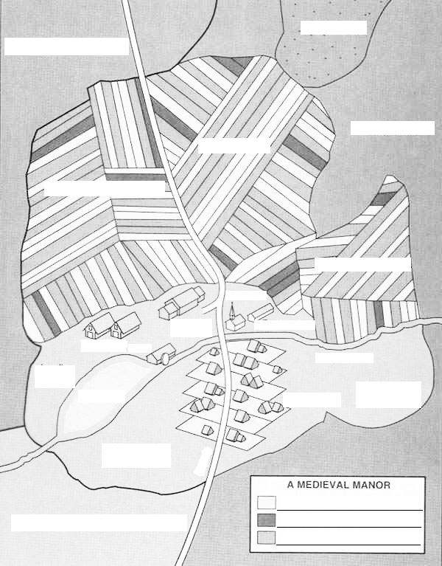
Label all of the above following on a map of a kingdom except Eleanor of Aquitaine. Explain the relationship among individuals or groups on the map.

Create a castle. Include defenses and offensive aspects in the castle to accumulate 15 total items in the castle. Answer questions 1 &2 on 221.
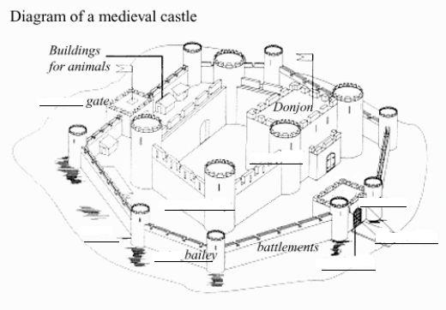
Choose one of the following and describe what the average day would be like for him or her and the relationship he/she would have with the others: a serf, troubadour, knight, woman, lord, or peasant.

