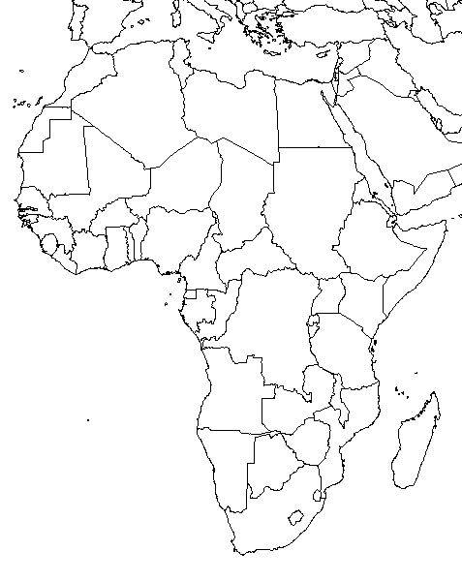

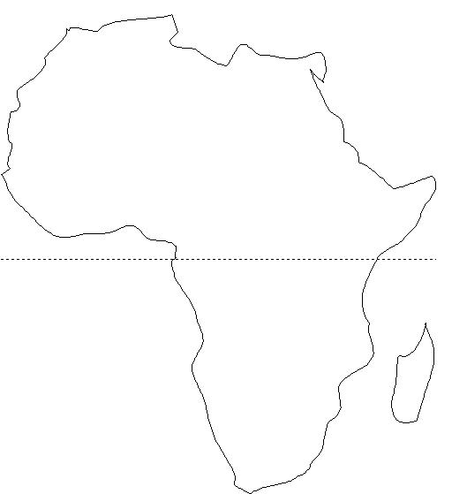

Label and color Batu migration, Sahara Desert, Libyan Desert, Kalahari Desert, Nile River, Lake Victoria, Mr. Kilimanjaro, Mediterranean Sea, Red Sea, Indian Ocean, Atlantic Ocean, Cape of Good Hope, trading routes, Great Rift Valley

